**Aim**: Perform dynamic routing protocol (RIP) and analyze the results.

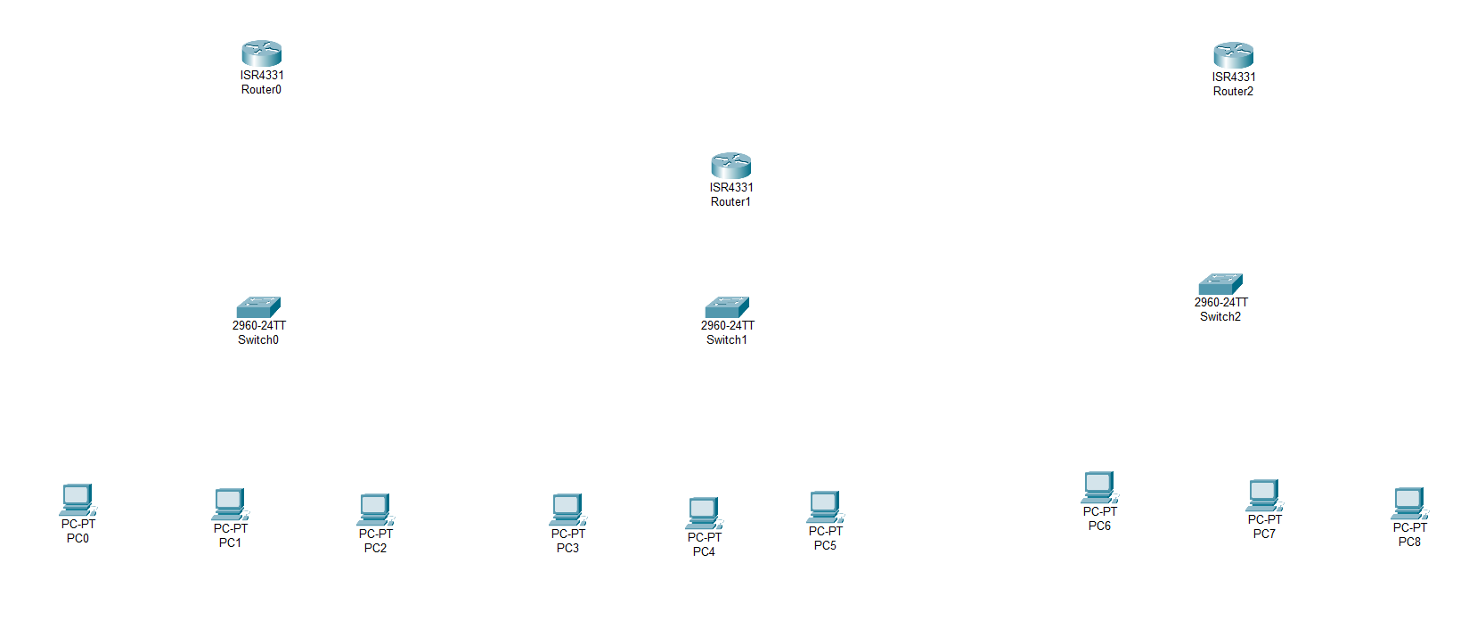**Step – 1:-** Open the Cisco Packet tracer and take three routers, three switch and nine PC’s.

**Step – 2 :-**  To long distance communication we need to connect router using Serial DTE cable. For the serial port we have to open router turn off it and drag and drop WIC-1T on router and turn on router.

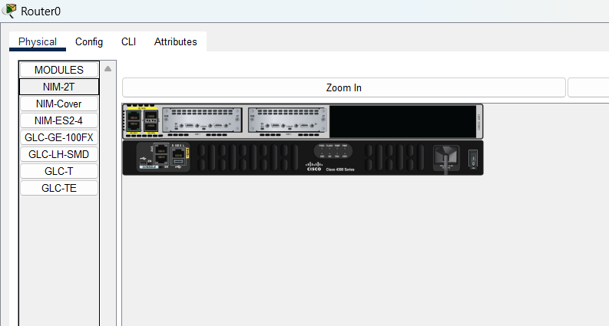

**Step – 3 :-**  Now Connect Two Routers Using Serial DTE Cable.

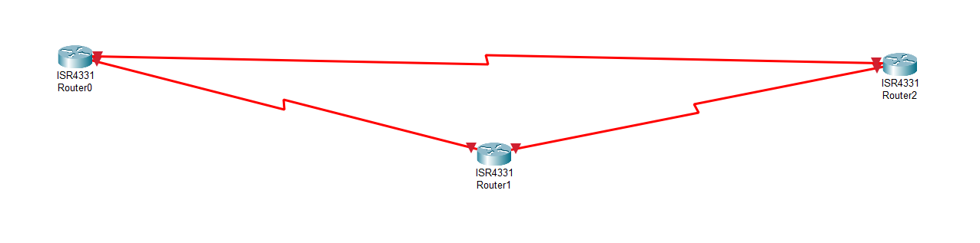

**Step – 4 :-**  Now Connect the Switches with routers using Copper Straight through cable In GigaEthernet Port.

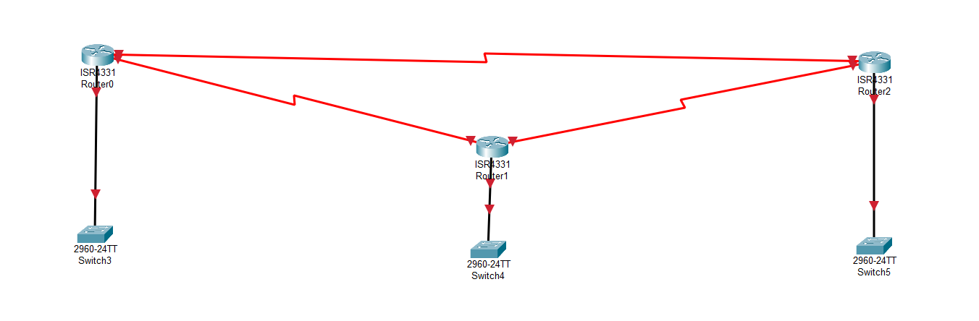

**Step – 5 :-**  Now Connect PC’s with Switches using copper Straight through cable.

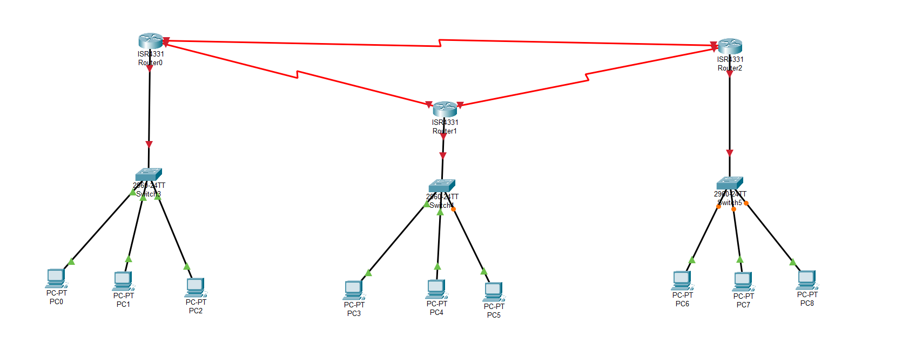

**Step – 6:-**  Now assign the IP address And Subnet mask and Gateway to all PC’s.

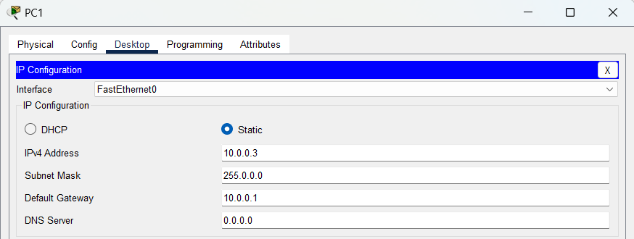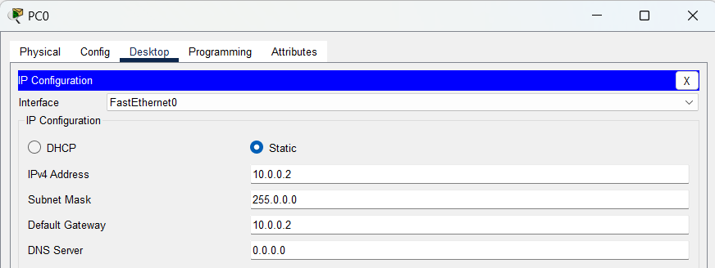

**Step – 7 :-**  Assign IP Address to Routers

**Step – 9 :-**  now we will check connection.

**Conclusion :-**

By Performing this experiment, we learned how to define the default gateway , how to route the packets , we learned how to add modules in routers , how to assign IP Address to the ports of router , learnt how to design a network.